INSTALLATION OF VS CODE

Riddhi Musale

PRN: 23070123108

Branch/Batch: EnTC B2

1)Go to chrome and search for vs code installation (https://code.visualstudio.com/docs/?dv=win64user)

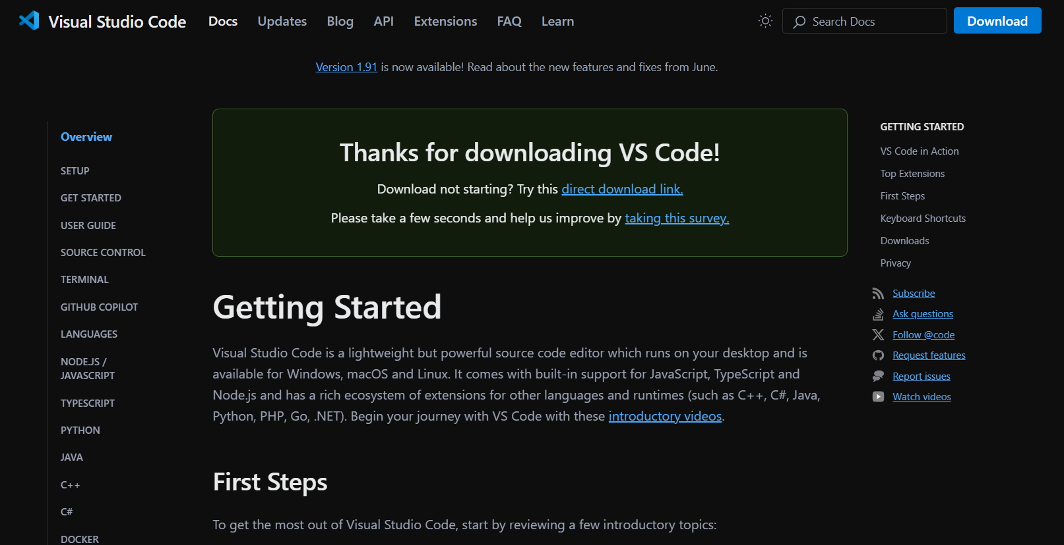

2) Click on “ I accept agreement” of the pop up which will appear, and then click on next.

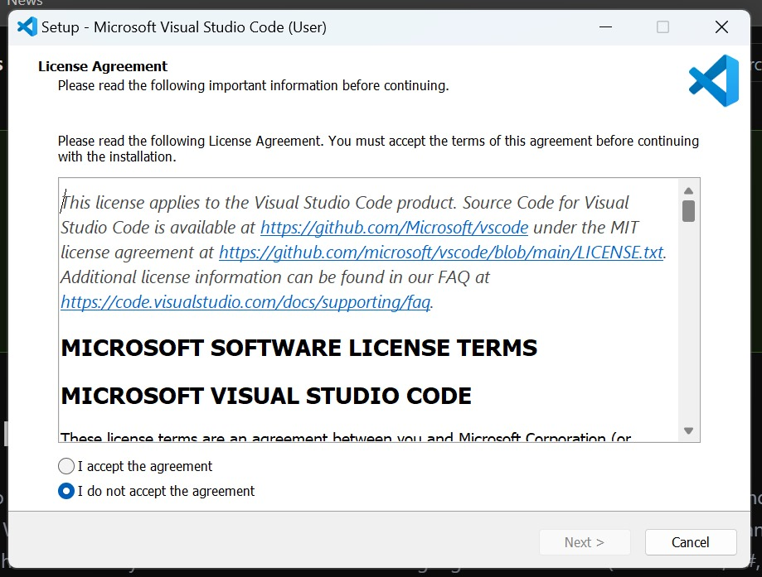

Installation of VS code

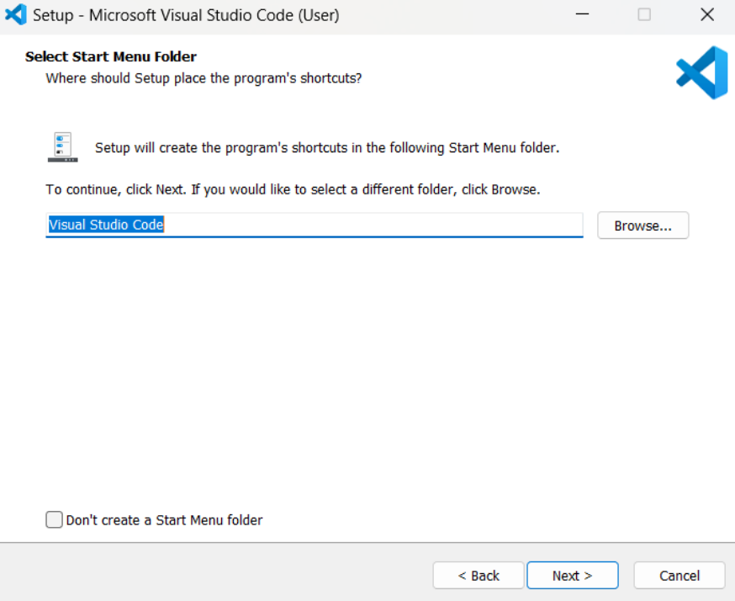

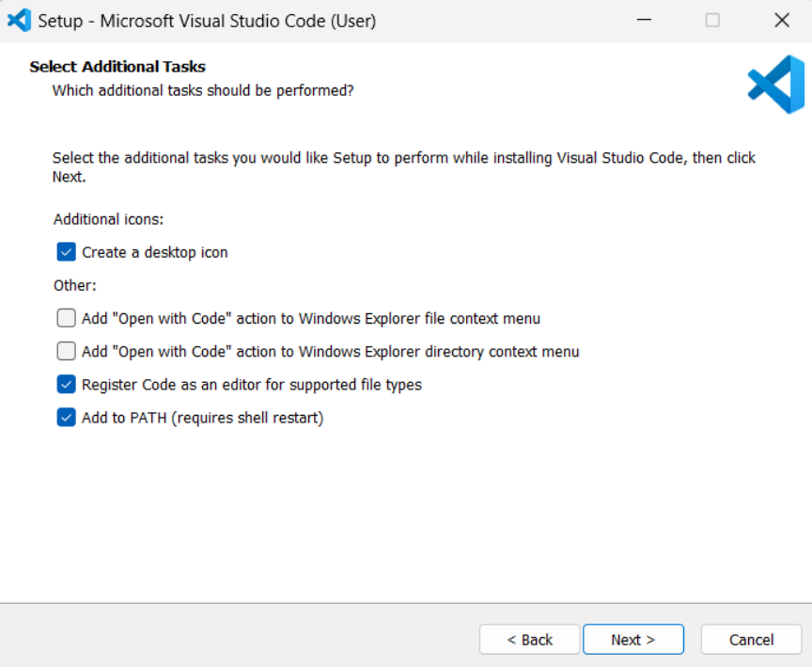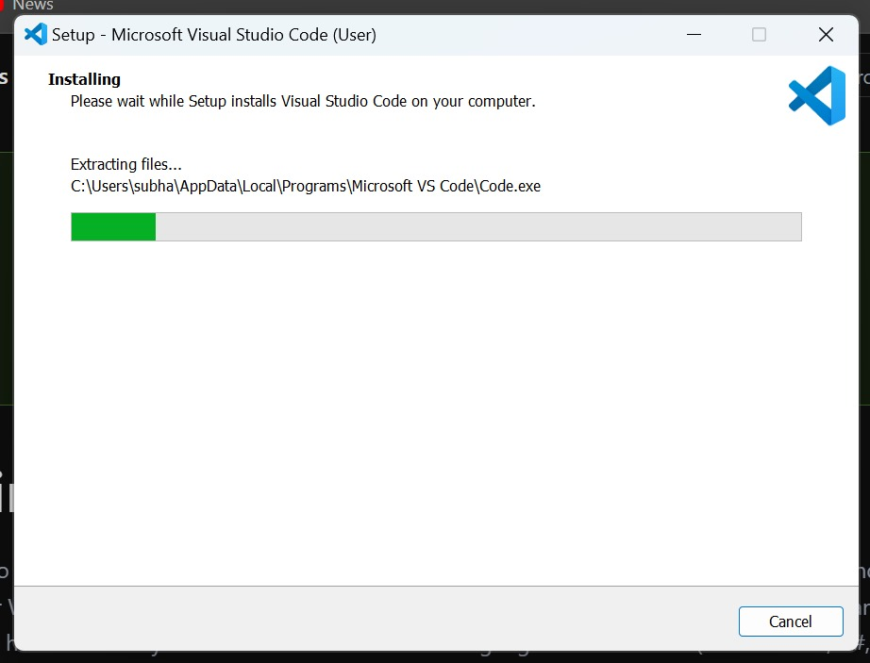

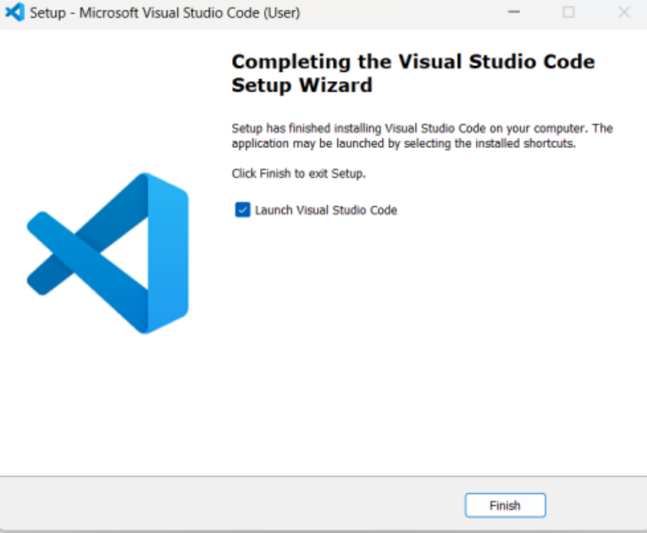

Downloading MinGW for compilation

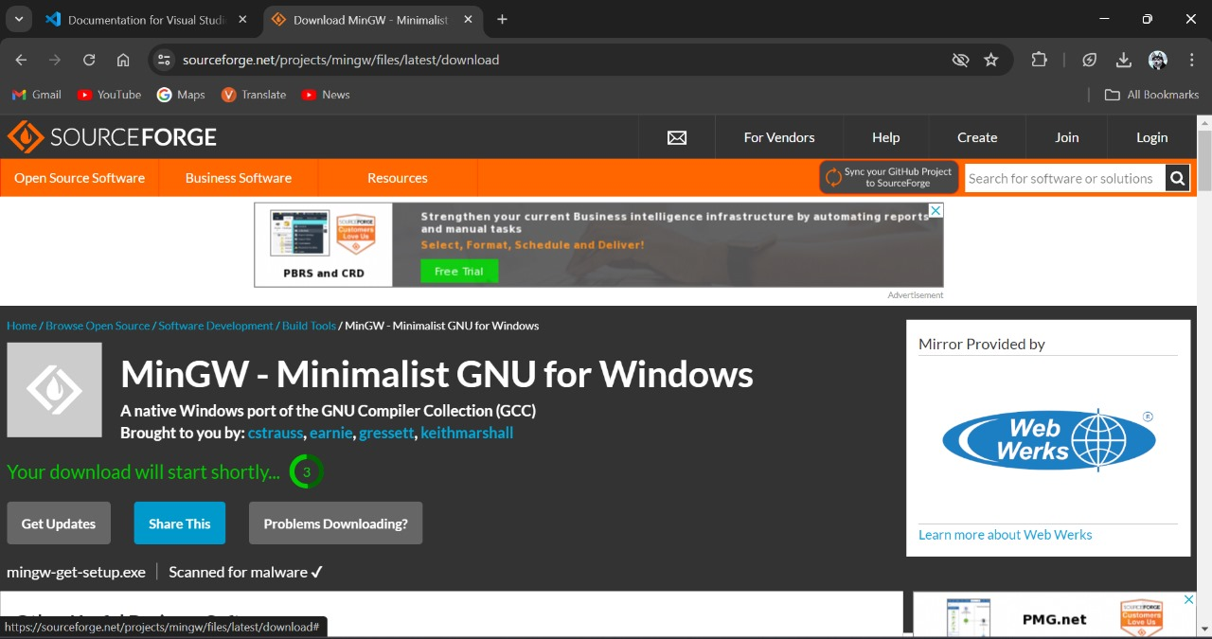

A pop up window will appear. Click on Install.

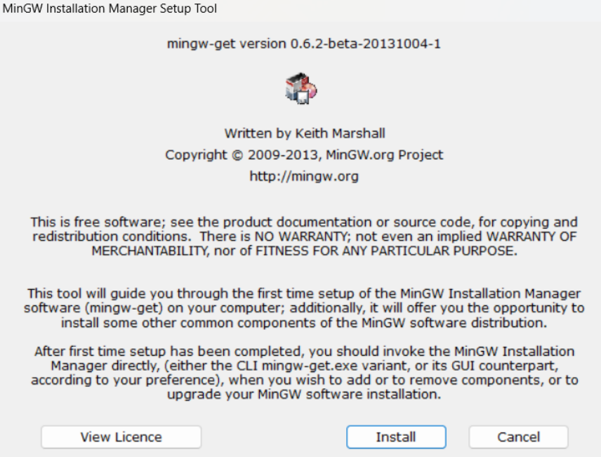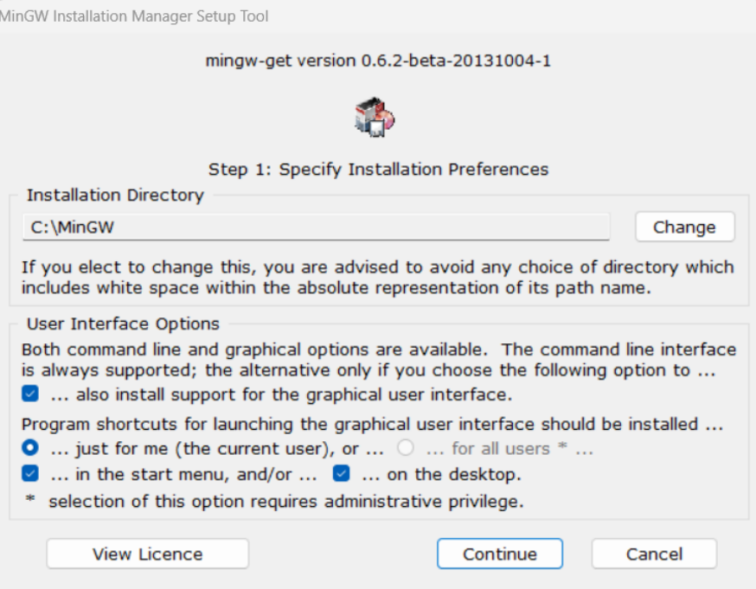

check all the required boxes for the C and C++ languages and click on Ap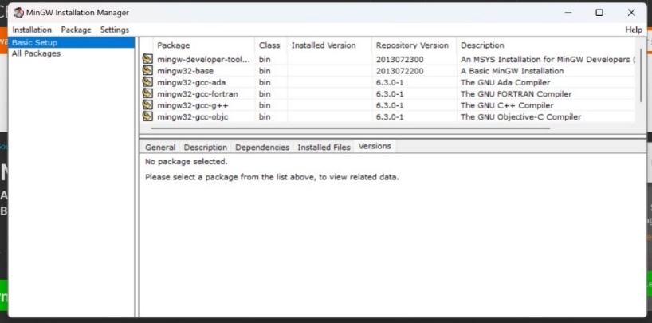

Now go to This PC, open MinGW folder, click on bin folder, a number of files will appear, Now copy its path.

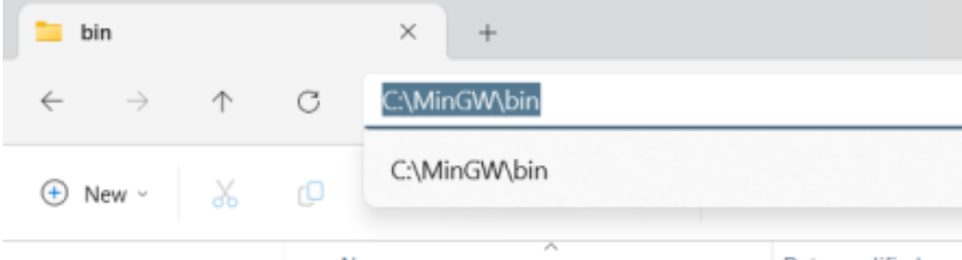

This PC, click on Advanced system settings, A pop up window will appear, click on Environmental variables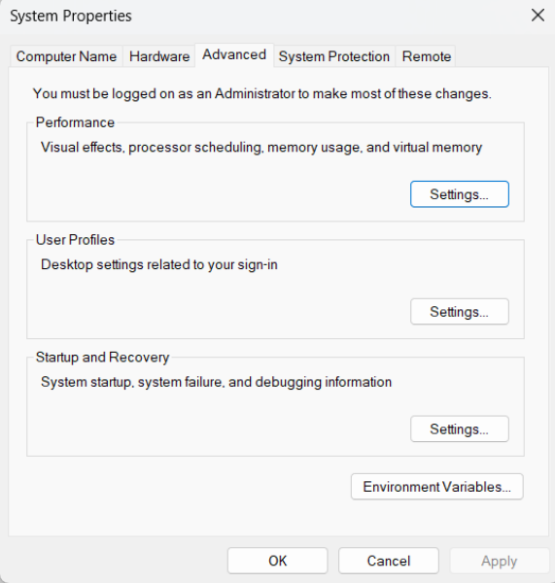

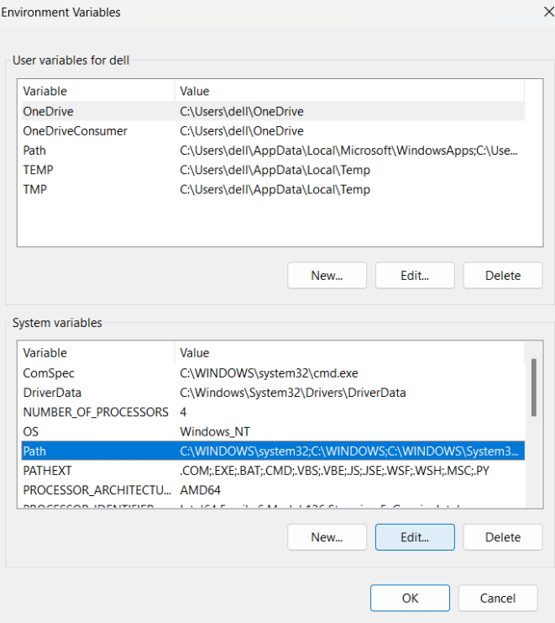

Click on New. Then paste the copied path. Then click on OK.

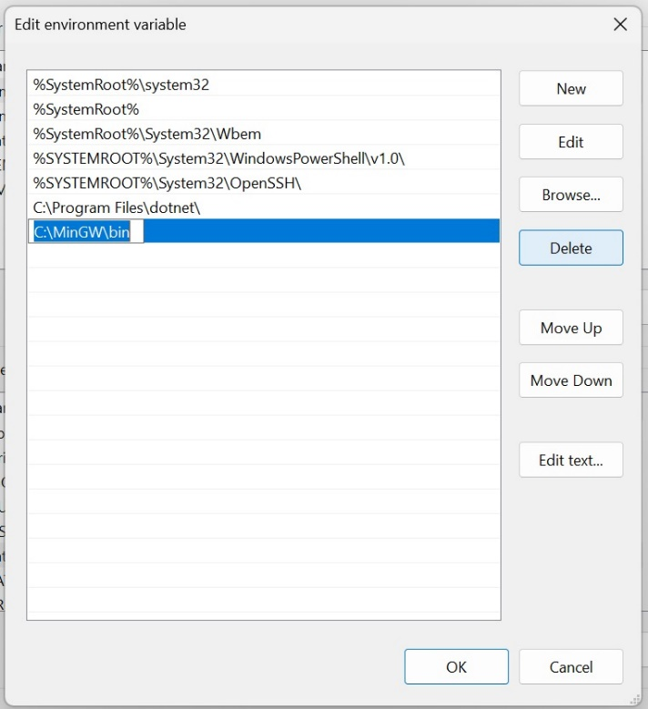

All changea are applied and you can use MinGW

